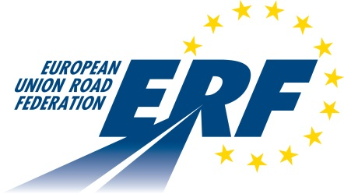 |  | 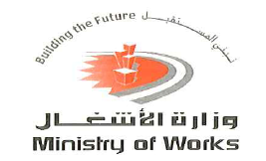

ERF SAFETY TRAINING

25-26 April 2016
Ministry of Works
Manama (Kingdom of Bahrain)

List of Participants
1 | Shaikha Yousif Yaqoob Alkhaja
2 | Ali Rashed Ali Aljawder
3 | Yasser Mohammed Ali Darwish
4 | Mohamed Ali Husain al Khabbaz
5 | Muneera Mohamed Mohamed Abdulla Alzayani
6 | Mohammed Mohammed Abdulfattah Ahmed
7 | Sawsan Amaar Mandeel
8 | Ali A.Kareem Jassim
9 | Abdulrahman Abdulrahim Abdulnabi Shams
10 | Mahmood Mohsen Jasim Mohsen Alsfoor
11 | Yousif Abdulamer Hameed Tarada
12 | Shaima Khalifa Ebrahim Hamdan
13 | Emeritus Badajos Tagarino
14 | Ali Abdulla Ahmed Almoot
15 | Ali Hasan Jassim Mohamed
16 | Ali Hassan Kadhim
17 | Dino Reyes Lanipa
18 | Cesar Lising Espino
19 | Mohamed Hasan Abbas Ali Hubail
20 | Mohammed Saeed Ebrahim Eid
21 | Hamed Ebrahim al Fayez
22 | Mohamed Abdulla Abdulkareem
23 | Muna al Ruwaili
24 | Gilbert Santos Fuentes
25 | Shahid Ashraf
26 | Karamchand M. Menon
27 | Kevin Harris
28 | Milagros Tomacder Alcaraz
29 | Mohammed Dashti
30 | Mohammad Ghabin
31 | Christophe Nicodème
32 | José Díez
33 | Jean Bloch
34 | Tony Everitt
35 | Joachim Leimer
36 | Gernot Sauter

